In this session, basic HTML is introduced.

You may follow the instructions below, to create the basic HTML page with the appropriate elements.  
Let’s start!

1. HTML starter pack. You should have this starter pack ready for your exercises.

<!DOCTYPE html>

<html lang="en">

<head>

<meta charset="utf-8" />

<meta name="description" content="Demonstrates some basic HTML content elements" />

<meta name="keywords" content="HTML5, tags" />

<meta name="author" content="A Lecturer" />

<title>Lecture 1-2 - HTML 5 Basic Content Elements</title>

</head>

<body>

</body>

**HEADER STYLES**

1. Create <h1> tag. Insert the scripting below after <body> tag. Header styles include <h1>, <h2>, <h3> to <h5>.

<h1>HTML 5 Elemens</h1>

<h1>HTML 5 Basic Content Elements</h1>

**LINK within page (TEXT)**

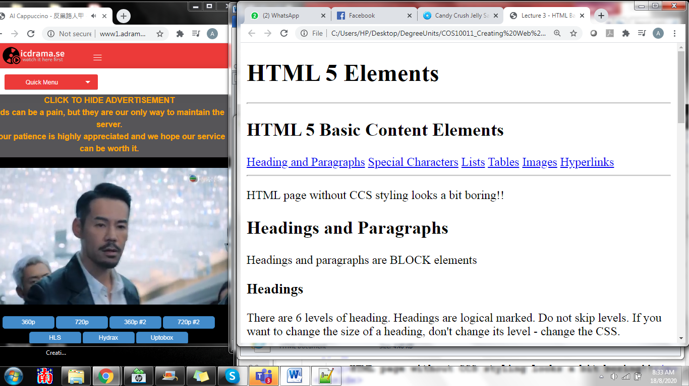

1. Let’s create a text link as above. Insert the following scripts to create the hyperlink within page to each text.

<a href=" #headings">Heading and Paragraphs</a>

<a href="#sc">Special Characters</a>

<a href="#lists">Lists</a>

<a href="#tables">Tables</a>

<a href="#images">Images</a>

<a href="#hyperlinks">Hyperlinks</a>

**PARAGRAPH**

1. Let’s work on the paragraph by using <p> tag. <h1> tag is reserved for header styles.

<p>HTML page without CCS styling looks a bit boring!!</p>

**HEADER STYLES AND PARAGRAPH**

1. You can prepare your content by using header styles and paragraph together.

<h2>Headings and Paragraphs </h2>

<p>Headings and paragraphs are BLOCK elements</p>

<h3>Headings</h3>

<p>There are 6 levels of heading. Headings are logical marked. Do not skip levels. If you want to change the size of a heading, don't change its level - change the CSS.</p>

<h3>Paragraphs</h3>

<p>Paragraphs contain the body text of a web page. You cannot put another block element inside a paragraph.</p>

**SPECIAL CHARACTER AND ID**

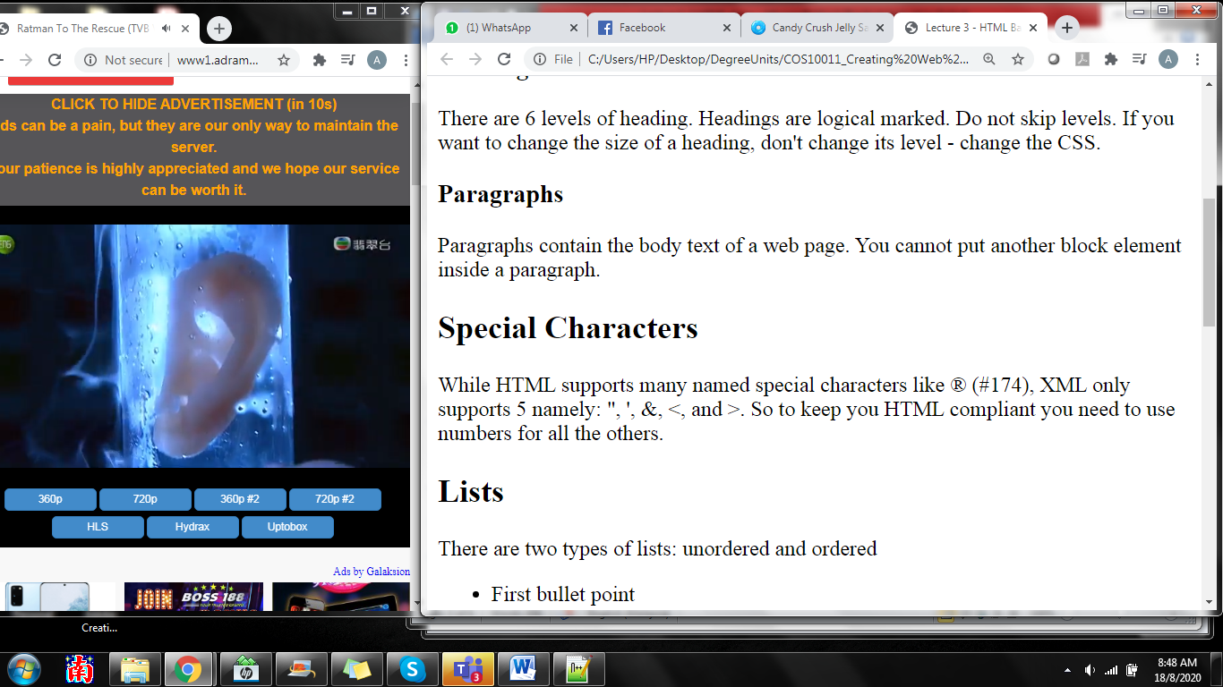

|  |  |  |  |  |  |  |  |  |  |
| --- | --- | --- | --- | --- | --- | --- | --- | --- | --- |
| “ | &quot; | ‘ | &apos; | & | &amp; | < | &lt; | > | &gt; |

1. There are codes to use for special characters as above. You may find the codes used under <p> tag. We will assign an id to this section and name the section as ‘sc’. This id will be used as link above.

<h2 id="sc">Special Characters</h2>

<p>While HTML supports many named special characters like &#174; (#174), XML only supports 5 namely: &quot; , &apos;, &amp;, &lt;, and &gt;. So to keep you HTML compliant you need to use numbers for all the others.</p>

**LISTING**

1. At this section, you will learn how to create number listing and bullet listing as below:

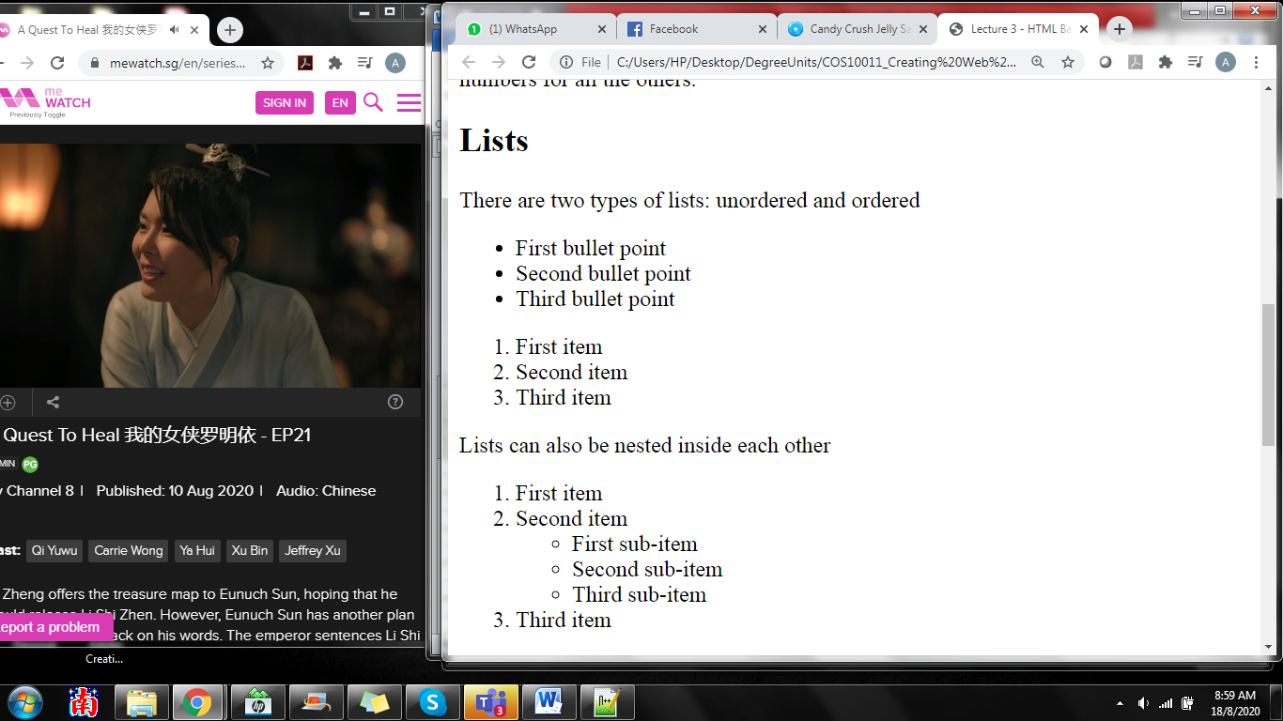

1. Let’s start with bullet listing by using the following script. Before that, create an id to this section, name the id as ‘list’.

<h2 id="list">Lists</h2>

<p>There are two types of lists: unordered and ordered</p>

<ul>

<li>First bullet point</li>

<li>Second bullet point</li>

<li>Third bullet point</li>

</ul>

1. Now, let’s continue with bullet listing by using the following script.

<h2 id="list">Lists</h2>

….

<ol>

<li>First item</li>

<li>Second item</li>

<li>Third item</li>

</ol>

1. How about to work with nested listing?

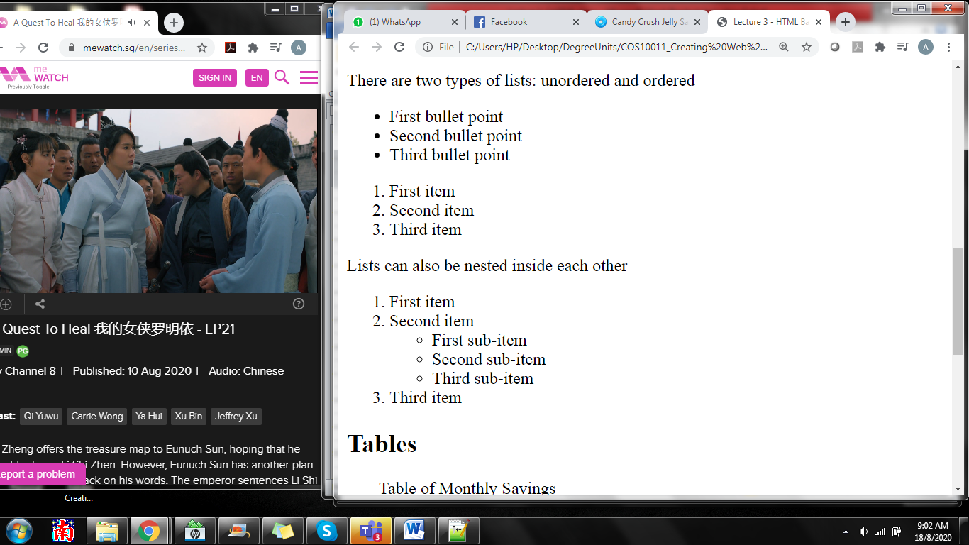

<h2 id="list">Lists</h2>

…

<p>Lists can also be nested inside each other</p>

<ol>

<li>First item</li>

<li>Second item</li>

<ul>

<li>First sub-item</li>

<li>Second sub-item</li>

<li>Third sub-item</li>

</ul>

</li>

<li>Third item</li>

</ol>

**TABLE (ROWs and COLUMNS)**

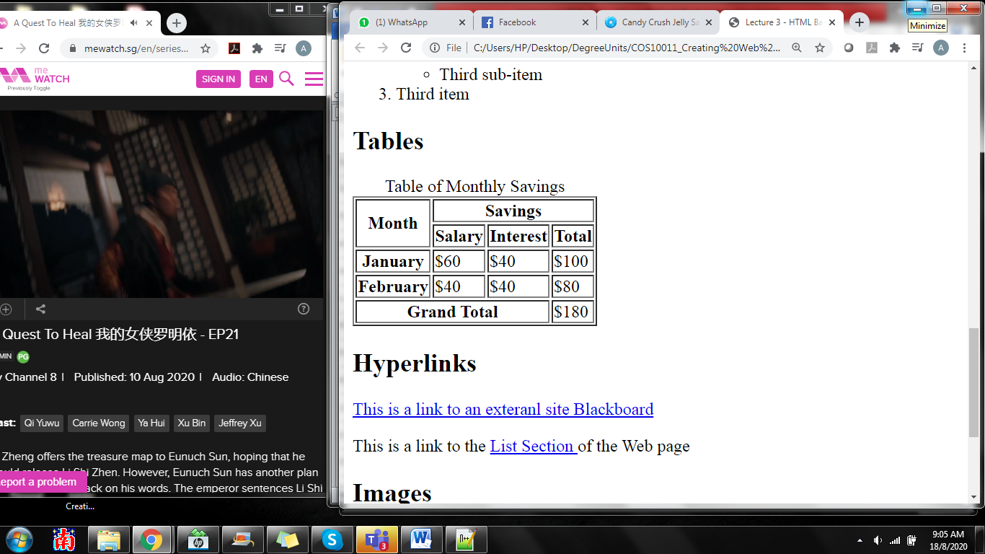

1. Let’s create a table as above. Let me ask a question, how many rows and columns here? It is 5 rows x 4 columns. Let’s work it together. We will start with an id section following by <table> tag. Do remember to close the table tag by using </table>. <Caption> tag is used for the title for the table.

<h1 id="tables">Tables</h1>

<table border="1">

<caption>Table of Monthly Savings</caption>

</table>

1. Now, let’s create 5 rows for this table.

<h1 id="tables">Tables</h1>

<table border="1">

<caption>Table of Monthly Savings</caption>

<tr></tr>

<tr></tr>

<tr></tr>

<tr></tr>

<tr></tr>

</table>

**Row 1**

1. We will work on row by row. Using the following script will give you 2 columns for first row. <th> tag is used to format these cells in heading format with bold and center. We will do merging format for these 2 columns. First column merges with 2 rows (rowspan =”2”) and second column merges with 3 columns (colspan = “3”).

<h1 id="tables">Tables</h1>

<table border="1">

<caption>Table of Monthly Savings</caption>

<tr>

<th rowspan="2" scope="col">Month</th>

<th colspan="3" scope="col">Savings</th>

</tr>

<tr></tr>

<tr></tr>

<tr></tr>

<tr></tr>

</table>

**Row 2**

1. Now using the following script for row 2.

<h1 id="tables">Tables</h1>

<table border="1">

<caption>Table of Monthly Savings</caption>

<tr>

<th rowspan="2" scope="col">Month</th>

<th colspan="3" scope="col">Savings</th>

</tr>

<tr>

<th scope="col">Salary</th>

<th scope="col">Interest</th>

<th scope="col">Total</th>

</tr>

<tr></tr>

<tr></tr>

<tr></tr>

</table>

**Row 3 & 4**

1. Create row 3 & 4 with 4 columns by using the following script.

<h1 id="tables">Tables</h1>

<table border="1">

<caption>Table of Monthly Savings</caption>

<tr>

<th rowspan="2" scope="col">Month</th>

<th colspan="3" scope="col">Savings</th>

</tr>

<tr>

<th scope="col">Salary</th>

<th scope="col">Interest</th>

<th scope="col">Total</th>

</tr>

<tr>

<th scope="row">January</th>

<td>$60</td>

<td>$40</td>

<td>$100</td>

</tr>

<tr>

<th scope="row">February</th>

<td>$40</td>

<td>$40</td>

<td>$80</td>

</tr>

<tr></tr>

</table>

**Row 5**

1. The last row of the table.

<tr>

<th colspan="3" scope="row"> Grand Total</th>

<td>$180</td>

</tr>

**HYPERLINK (TEXT AND PICTURE)**

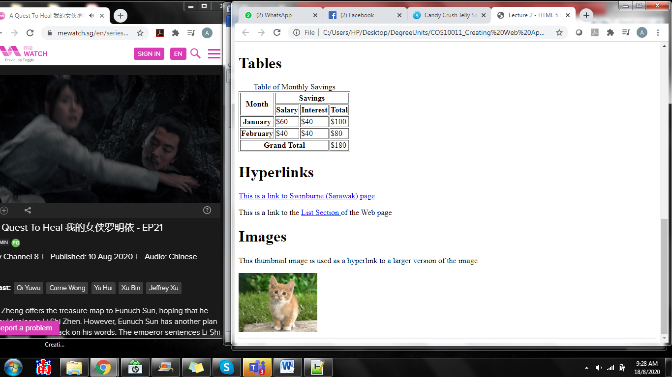

1. Create a hyperlink (text) which link to a website.

<h1 id="hyperlinks">Hyperlinks</h1>

<p><a href="http://www.swinburne.edu.my" title="This takes you to Blackboard"> This is a link to Swinburne (Sarawak) page</a></p>

<p>This is a link to the <a href="#list">List Section </a> of the Web page</p>

1. Lastly, insert a picture and using the picture as a link to another source.



<h1 id="images">Images</h1>

<p>This thumbnail image is used as a hyperlink to a larger version of the image</p>

<a href="mycat.jpg"> <img src="mycat_small.jpg" alt="Photo of my cat" title="Filesize 222kb " /></a>